**AZURE CLI Windows**

To install azure CLI we need to install NodeJs

So one this link and download NodeJs for windows and install it

<http://nodejs.org/download/>

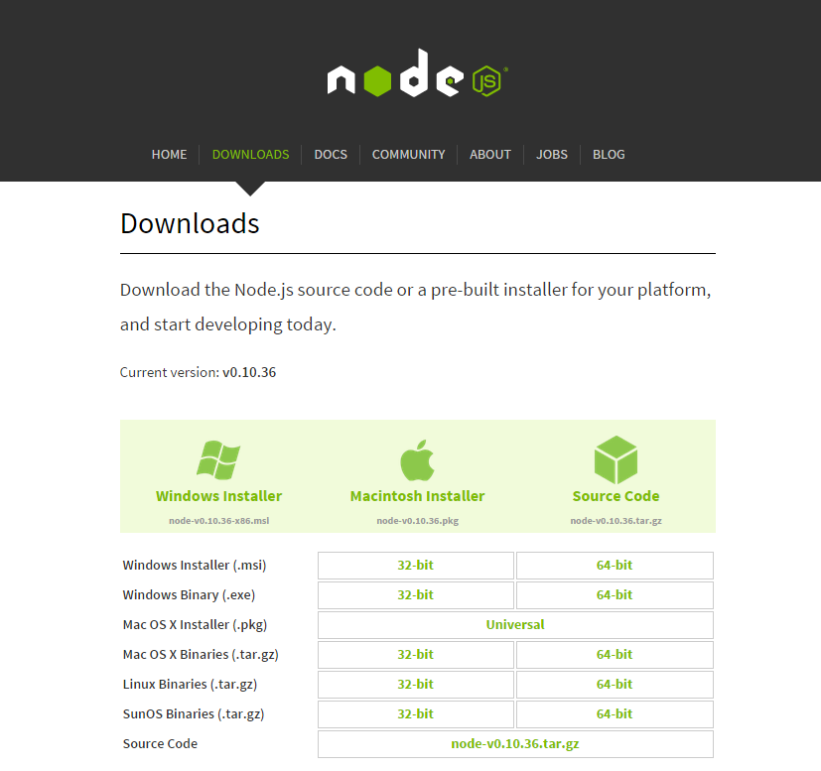

Now Open up a CMD

And run this

* *npm*

(this is nodejs package manager)

If you are running windows 8.1 you might get an error running npm

Something like this

**C:\Users\Rotem\Downloads>npm**

**Error: ENOENT, stat 'C:\Users\Rotem\AppData\Roaming\npm'**

To resolve this issue we need to go and create npm folder in your AppData\Roaming folder

So go ahead and run this command

* *mkdir C:\Users\<username>\AppData\Roaming\npm*

Now we will install Azure cli using npm

* *npm install -g azure-cli*

After all is over run the next command

* *azure*

You should see something like this

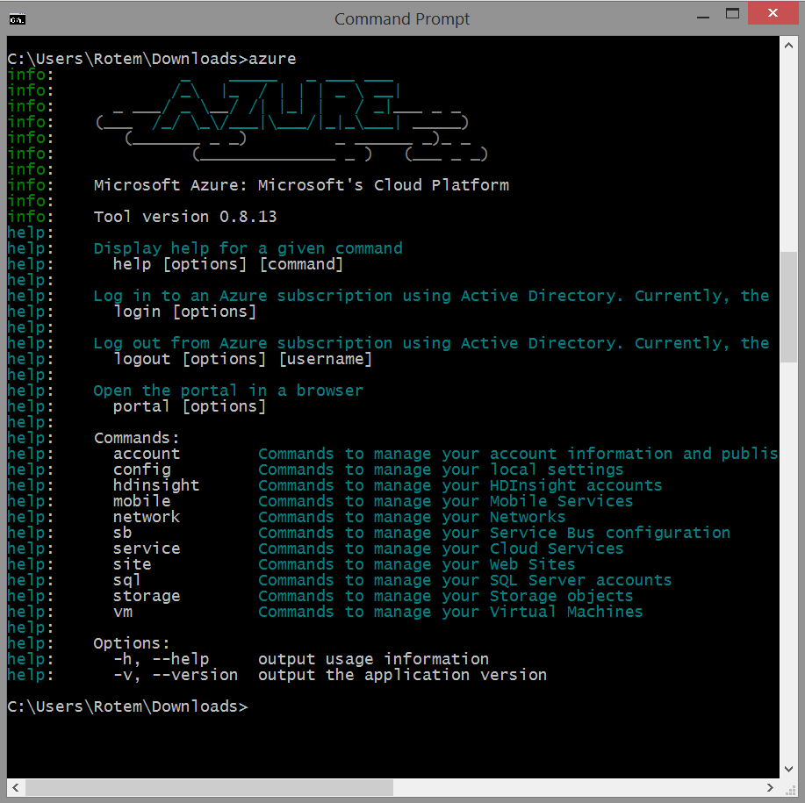

Now you need to import your azure subscription

it will open up your default browser and you will be able to download your subscription settings file

* *azure account download*

if you have multiple accounts you can select the desired account

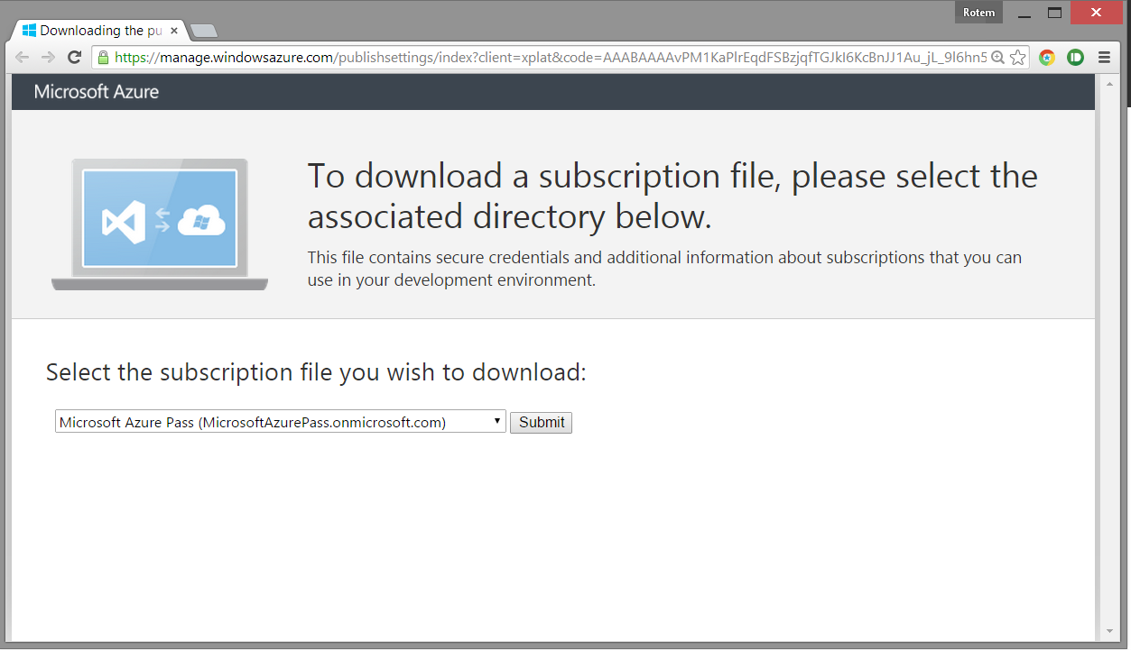

Now Lets import the publish settings file

* *azure account import <file path>*

When its done you can start running commands against your azure account

Work with Azure CLI on Websites

- azure site create --location "West Europe" "SiteName"

- azure site list

- azure site list -v / -verbose

- azure site stop "sitename"

- azure site start "sitename"

- azure site delete "sitename"

Work with Azure CLI on VM

// show azure avaliable images

- azure vm image list

azure vm create myvmdemoname b39f27a8b8c64d52b05eac6a62ebad85__Ubuntu-12_04_5-LTS-amd64-server-20140806-en-us-30GB rotem --location "West US" vm-size "Small" -r

// show your images

- azure vm list

SCRIPT AZURE-CLI

- azure site list | grep 'Stopped' | awk '{system("azure site start "mytestclisite)}'